**Flowchart A | Study design with recruitment sites and patient separation**

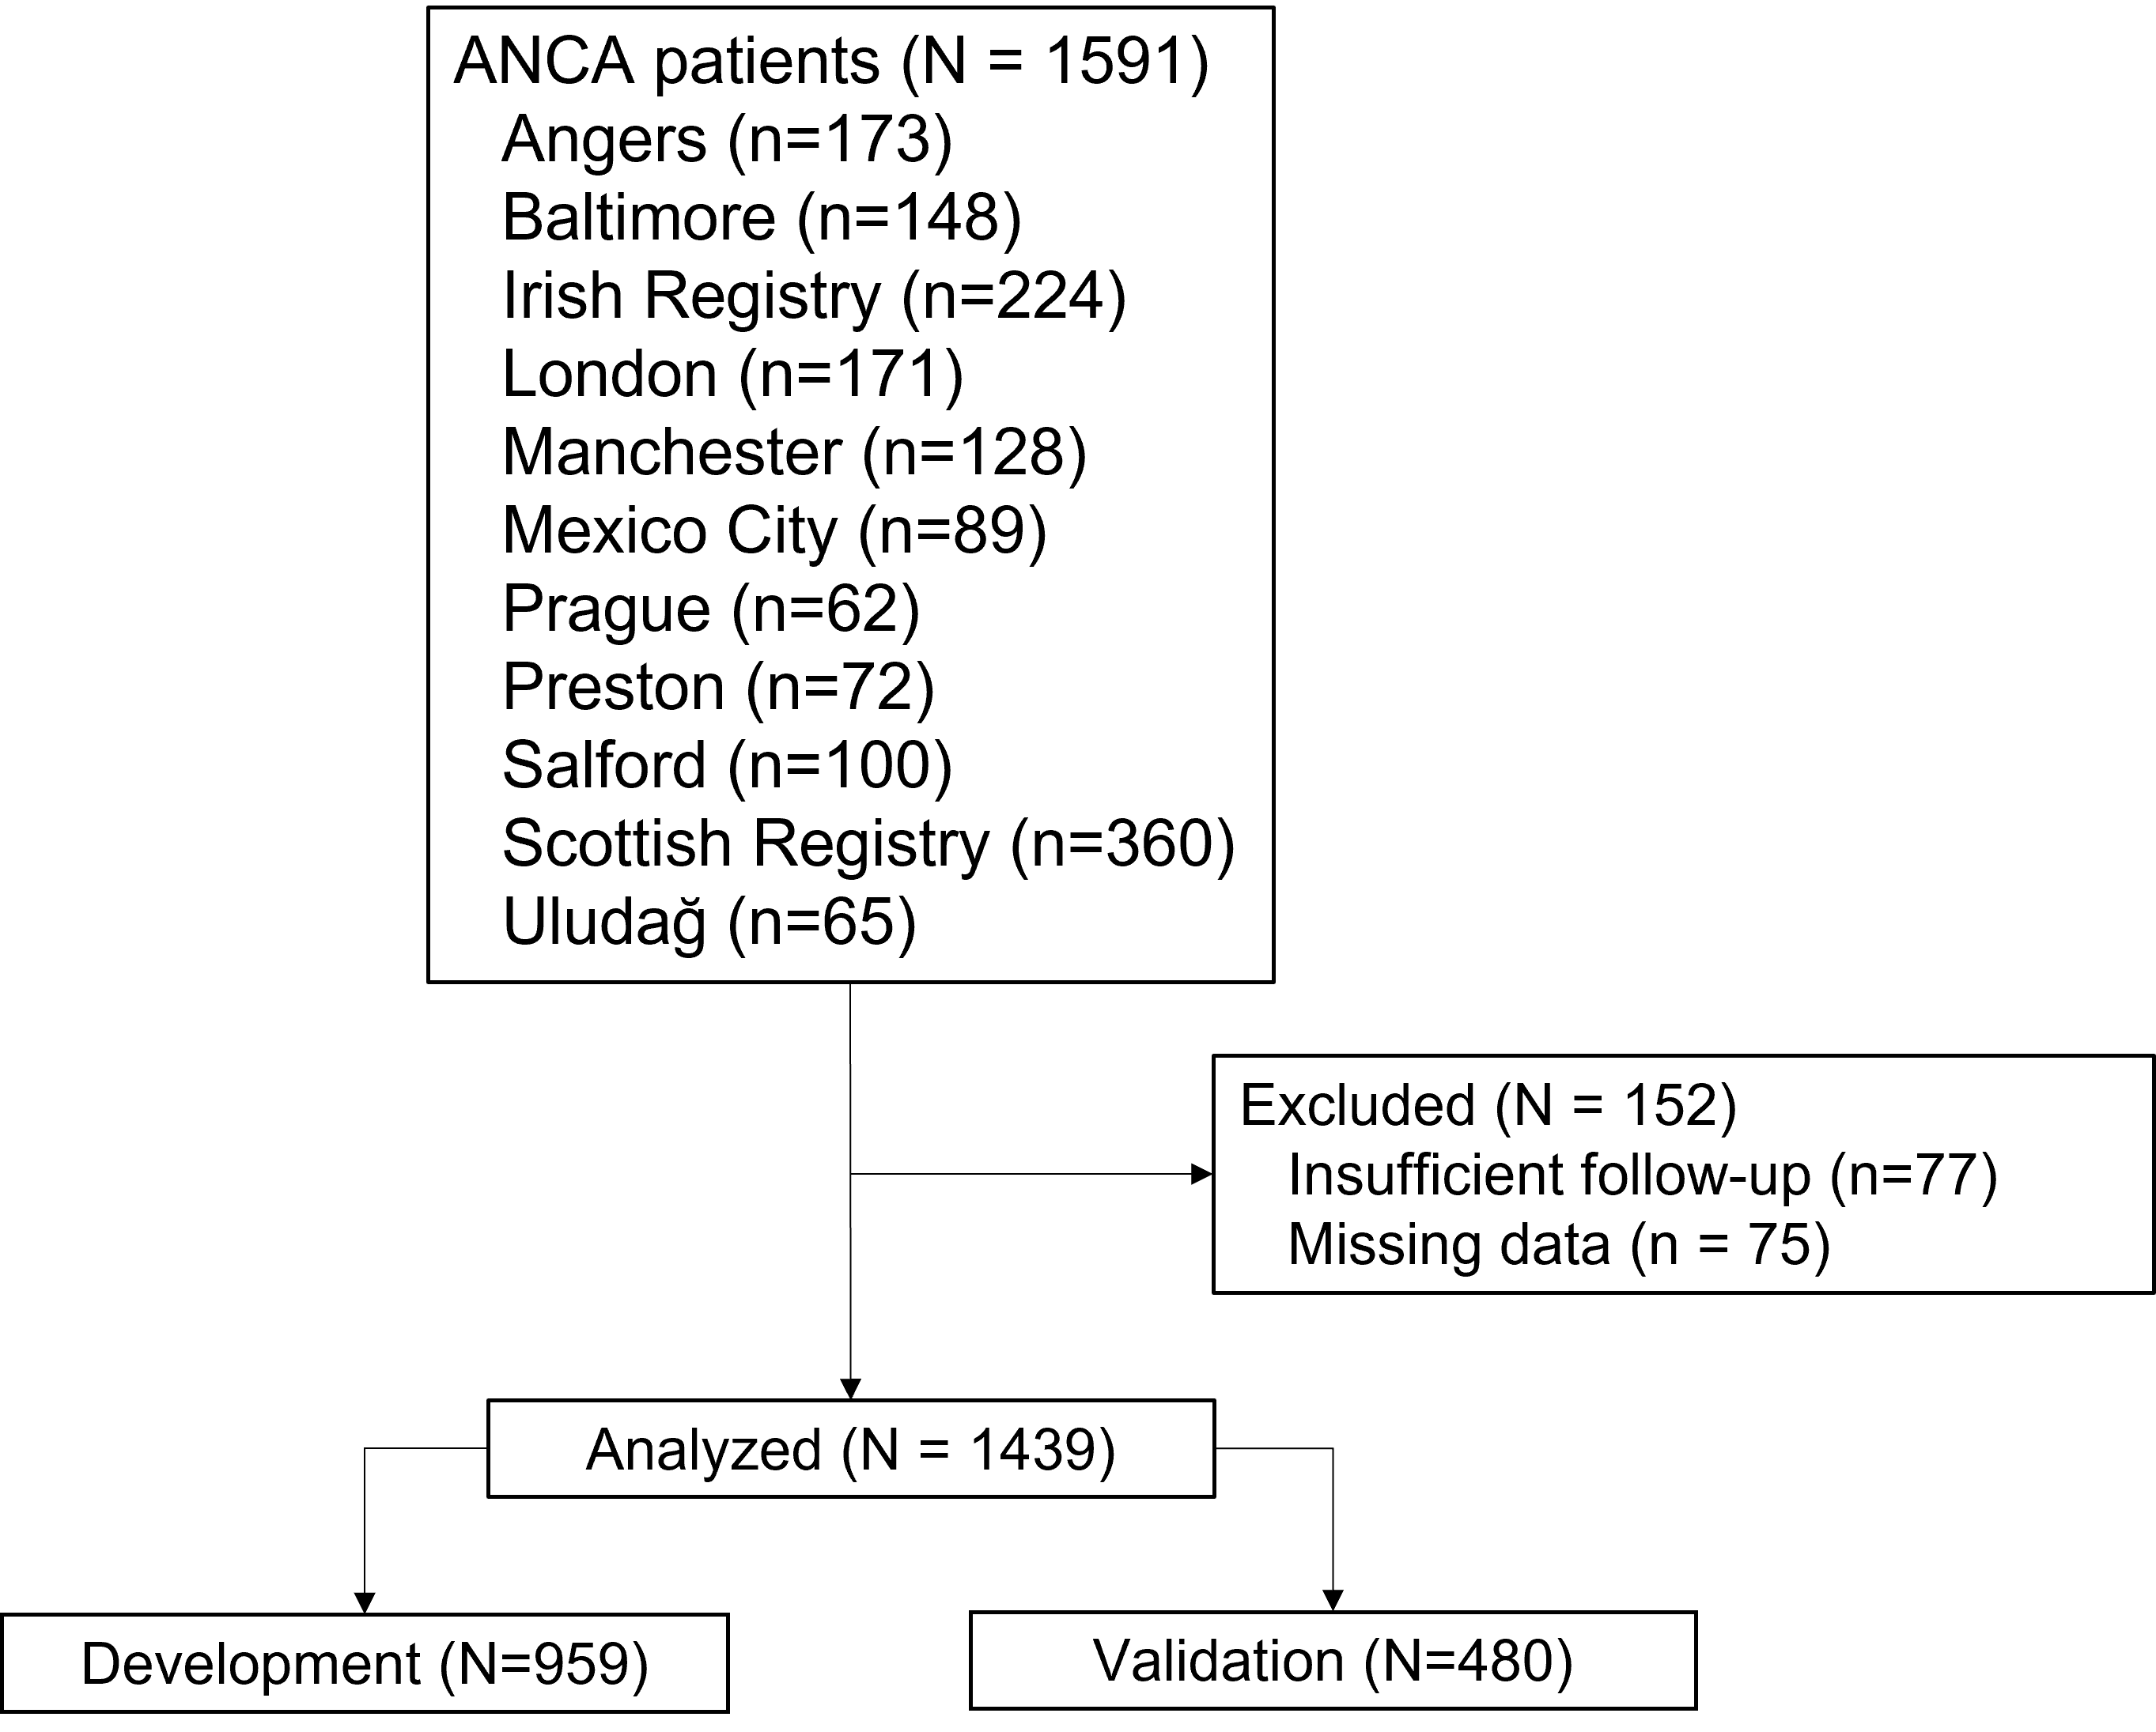

**Flowchart B | patient flow through study**

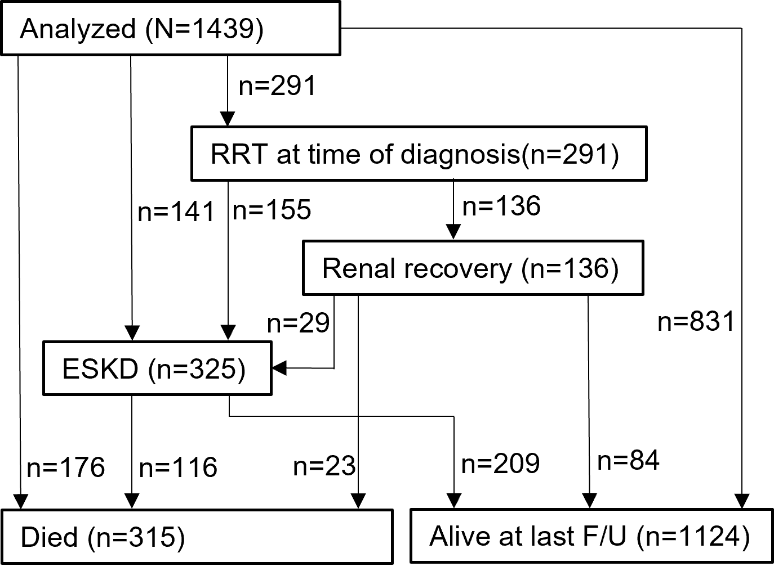

**Supplementary Table 1 | Basic characteristics and outcome of complete cohort, development, and validation cohorts**

|  | Development Cohort  (N = 959) | Validation Cohort  (N = 480) | P |
| --- | --- | --- | --- |
| Age at diagnosis (yr) | 63.4 (52.3-72.5) | 64.5 (53.9-73.2) | 0.449 |
| Sex Male | 484 (50.5%) | 266 (55.4%) | 0.086 |
| Diagnosis† |  |  |  |
| GPA | 388 (40.5%) | 180 (37.5%) | 0.588 |
| MPA | 538 (56.1%) | 282 (58.8%) |  |
| EGPA | 14 (1.5%) | 5 (1.0%) |  |
| ANCA Negative | 19 (2.0%) | 12 (2.5%) |  |
| ANCA type |  |  |  |
| Myeloperoxidase | 509 (53.1%) | 253 (52.7%) | 0.626 |
| Proteinase 3 | 389 (40.6%) | 190 (39.6%) |  |
| ANCA Negative | 61 (6.4%) | 37 (7.7%) |  |
| eGFR (ml/min/1.73m2) | 21.8 (11.3-38.0) | 18.0 (9.8-35.0) | 0.026 |
| Creatinine (μmol/L) | 225.0 (147.0-383.5) | 257.0 (157.5-449.5) | 0.015 |
| Initial Need for RRT | 185 (19.3%) | 106 (22.1%) | 0.240 |
| Glomeruli on biopsy | 17.0 (12.0-23.0) | 17.0 (12.0-23.2) | 0.718 |
| Percentage Normal Glomeruli | 36.0 (14.3-66.7) | 34.7 (14.3-62.5) | 0.296 |
| Percentage Crescentic Glomeruli | 19.0 (5.8-44.4) | 21.4 (6.3-50.0) | 0.292 |
| IFTA |  |  |  |
| None - Mild | 469 (48.9%) | 220 (45.8%) | 0.297 |
| Mild to Moderate - Severe | 490 (51.1%) | 260 (54.2%) |  |
| Renal Risk Score | 3.0 (0.0-7.0) | 4.0 (2.0-7.0) | 0.150 |
| Risk Group |  |  |  |
| Low | 258 (26.9%) | 112 (23.3%) |  |
| Moderate | 484 (50.5%) | 258 (53.8%) |  |
| High | 217 (22.6%) | 110 (22.9%) |  |
| Data presented as n (%) or median (interquartile range). The eGFR was calculated using the Chronic Kidney Disease Epidemiology Collaboration (CKD EPI) equation24. ANCA, anti-neutrophil cytoplasmic antibody; eGFR, estimated glomerular filtration rate; EGPA, eosinophilic granulomatosis with polyangiitis; GPA, granulomatosis with polyangiitis; IFTA, interstitial fibrosis and tubular atrophy; MPA, microscopic polyangiitis; RRT, renal replacement therapy. | | | |

**Supplementary Table 2 | Clinical outcomes**

|  | Development Cohort  (N=959) | Validation Cohort  (N=480) | P |
| --- | --- | --- | --- |
| Follow-up (years) | 3.6 (1.1-5.9) | 3.6 (1.0-6.0) | 0.770 |
| Renal recovery | 83/185 (44.9%) | 53/106 (50%) | 0.681 |
| ESKD | 207 (14.4%) | 118 (8.2%) | 0.254 |
| Mortality | 206 (14.3%) | 109 (7.6%) | 0.504 |

**Supplementary Table 3 | Validated 3-year survival**

|  |  |  |
| --- | --- | --- |
| Group | Original 3-year renal survival | Validated 3-year renal Survival |
| Low | 100% | 94.8% |
| Medium | 84% | 86.1% |
| High | 32% | 52.4% |

**Supplementary Table 4 | Parameters of the continuous model**

|  |  |  |
| --- | --- | --- |
|  |  | $$β$$ |
| Creatinine | Log(μmol) | 1.250 |
| Normal Glomeruli | % | -0.0167 |
| IFTA | ≥25% | 0.616 |
|  | **C Statistic** | **0.833** |
| Survival function in supplementary Equation 1; model valid up to t=10 years; log, natural logarithm | | |

**Supplementary Table 5 | Patient cohorts divided by endpoint**

|  | No ESKD (N = 752) | ESKD (N = 207) |
| --- | --- | --- |
| Age at diagnosis (yr) | 64.1 (53.9-73.1) | 62.0 (50.5-70.9) |
| Sex Male | 567 (50.9%) | 183 (56.5%) |
| Diagnosis |  |  |
| GPA | 443 (39.8%) | 125 (38.5%) |
| MPA | 632 (56.7%) | 188 (57.8%) |
| EGPA | 16 (1.4%) | 3 (0.9%) |
| ANCA Negative | 22 (2.0%) | 9 (2.8%) |
| ANCA type |  |  |
| Myeloperoxidase | 509 (53.1%) | 253 (52.7%) |
| Proteinase 3 | 389 (40.6%) | 190 (39.6%) |
| ANCA Negative | 61 (6.4%) | 37 (7.7%) |
| eGFR (ml/min/1.73m2) | 25.0 (14.0-41.3) | 9.0 (5.8-16.0) |
| Creatinine (μmol/L) | 201.6 (136.0-314.7) | 471.0 (300.6-708.0) |
| Initial Need for RRT | 108 (9.7%) | 183 (56.5%) |
| Glomeruli on biopsy | 17.0 (12.0-24.0) | 16.0 (12.0-22.0) |
| Percentage Normal Glomeruli | 42.9 (22.2-70.0) | 13.3 (0.0-33.3) |
| Percentage Crescentic Glomeruli | 20.0 (5.6-43.4) | 24.0 (7.1-51.9) |
| TA/IF |  |  |
| None - Mild | 587 (52.6%) | 102 (31.5%) |
| Mild to Moderate - Severe | 528 (47.4%) | 222 (68.5%) |
| Renal Risk Score | 2.0 (0.0-5.0) | 8.0 (5.0-11.0) |
| Risk Group |  |  |
| Low | 348 (31.2%) | 22 (6.8%) |
| Moderate | 610 (54.8%) | 132 (40.6%) |
| High | 156 (14.0%) | 171 (52.6%) |
| Data presented as n (%) or median (interquartile range). The eGFR was calculated using the Chronic Kidney Disease Epidemiology Collaboration (CKD EPI) equation24. ANCA, anti-neutrophil cytoplasmic antibody; eGFR, estimated glomerular filtration rate; EGPA, eosinophilic granulomatosis with polyangiitis; GPA, granulomatosis with polyangiitis; IFTA, interstitial fibrosis and tubular atrophy; MPA, microscopic polyangiitis; RRT, renal replacement therapy. | | |

**Supplementary Table 6 | Univariable models for ESKD**

|  | HR | 95% CI | P |
| --- | --- | --- | --- |
| Age | 0.998 | (0.990-1.005) | 0.500 |
| Sex: Male | 0.846 | (0.680-1.054) | 0.135 |
| Antibody: PR3 | 0.940 | (0.744-1.187) | 0.601 |
| eGFR | 0.937 | (0.927-0.947) | <0.001 |
| Log(Creatinine) | 4.524 | (3.847-5.320) | <0.001 |
| Percentage Normal Glomeruli | 0.970 | (0.965-0.975) | <0.001 |
| Percentage Crescentic Glomeruli | 1.006 | (1.002-1.010) | 0.005 |
| IFTA: mild to Moderate - Severe | 2.307 | (1.824-2.917) | <0.001 |
| Reference categories: Female, GPA, MPO, None-Mild. CI, confidence interval; eGFR, estimated glomerular filtration rate; GPA, granulomatosis with polyangiitis; HR, hazard ratio; IFTA, interstitial fibrosis and tubular atrophy; log, natural logarithm; MPA, microscopic polyangiitis; MPO, myeloperoxidase; PR3, proteinase 3. | | | |

**Supplementary Table 7 | Multivariable for ESKD**

|  | HR | CI | P |
| --- | --- | --- | --- |
| Age | 1.010 | (0.998-1.022) | 0.108 |
| Sex: Male | 1.361 | (0.960-1.929) | 0.083 |
| Antibody: PR3 | 0.847 | (0.602-1.191) | 0.340 |
| eGFR | 1.029 | (1.013-1.045) | <0.001 |
| Log(Creatinine) | 5.918 | (3.909-8.960) | <0.001 |
| Percentage Normal Glomeruli | 0.974 | (0.964-0.984) | <0.001 |
| Percentage Crescentic Glomeruli | 0.996 | (0.991-1.002) | 0.197 |
| TA/IF: Mild to Moderate - Severe | 1.735 | (1.196-2.518) | 0.004 |
| Reference categories: Female, GPA, MPO, None-Mild. CI, confidence interval; eGFR, estimated glomerular filtration rate; GPA, granulomatosis with polyangiitis; HR, hazard ratio; IFTA, interstitial fibrosis and tubular atrophy; log, natural logarithm; MPA, microscopic polyangiitis; MPO, myeloperoxidase; PR3, proteinase 3. | | | |